Specification: software for STM32 Nucleo motor controller
- Introduction
A set of two BLDC motors must be controlled by a STM32 Nucleo-F103RB board. Required cycle see graph below:
- Both motor1 and motor 2 start at the same time and stop at the same time, both with the same given interval.
- Each motor must run at its own given constant speed
- A closed loop control (PID-control) is required to maintain the constant speed per motor at its target speed.
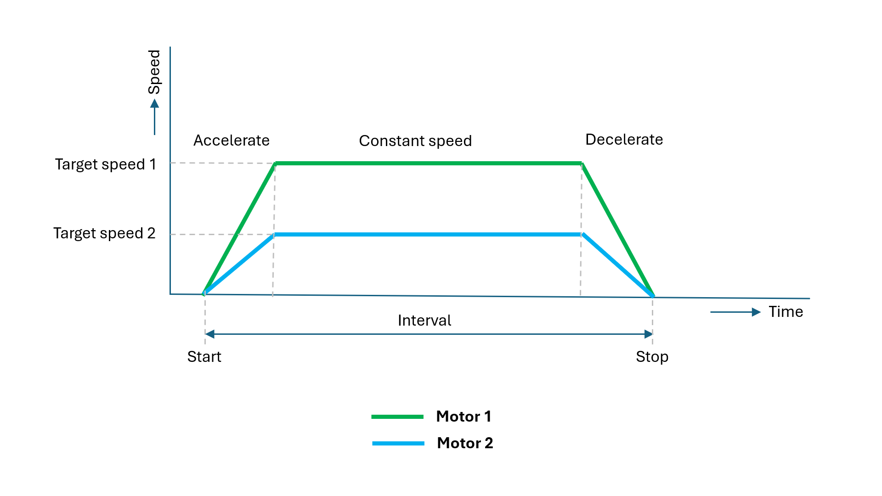

- BLDC motor specification
- Each BLCD motor has 4 wires
  - PWM signal with a frequency of 20kHz as an input
    - PWM control level “low”: ≤0.5V
    - PWM control level “high” 2.7 … 5.5V
  - Tacho signal as an output
    - FG-output pulses: 6 pulses / revolution
    - FG-output pulse time “low”: 50%
    - FG-output level “high” (no load): 5 … 6V
    - FG-output level “low” (no load): <0.5V
  - + supply voltage (connected to external power supply)
  - – supply voltage (connected to external power supply)
- Software requirements for the STM32 Nucleo-F103RB board
- Programmed fixed in the C-program
  - One fixed PWM signal frequency setting of 20kHz for both motor 1 and motor 2
  - Target speed setting of 1900 rpm for motor 1
  - Target speed setting of 800 rpm for motor 2
  - PID parameter settings for motor 1
  - PID parameter settings for motor 2
  - One interval setting (time between start and stop) of 35 seconds for both motor 1 and motor 2
- Input 1: Start the interval with an input pulse HIGH (for a momentary push button)
- Input 2: Tacho signal from motor 1
- Input 3: Tacho signal from motor 2
- Output 1: PWM signal for motor 1
- Output 2: PWM signal for motor 2
- Plot speed of motor 1 and speed of motor 2 vs time elapsed using SWV data trace timeline graph in STM32CubeIDE
- Write cumulative rotations of motor 1 and motor 2 after completing a cycle in STM32CubeIDE
- Required scope of delivery
- Functional software for the STM32 Nucleo-F103RB board as described above
- Software suitable for uploading via STM32CubeIDE version 1.17.0 by us to our own STM32 Nucleo-F103RB board for testing the complete system with the motors and power supply.

